Chile, December 10th , 2006

INVITATION

THE CHILE’S MOUNTAINEERING FEDERATION AND UPAME, CLIMBING & MOUNTAINEERING PANAMERICAN CONFEDERATION INVITES YOU TO THOSE PEOPLE INTERESTED TO PARTICIPATE ON OUR “CHILE, BIG 6000’S ON ACONCAGUA MAIPO AREA EXPEDITION, UPAME 2007”.

“CHILE, BIG 6000’S ON ACONCAGUA MAIPO AREA EXPEDITION, UPAME 2007”

1. ANTECEDENTES
In ordinary general assembly of UPAME (Pan-American Union of Mountain associations and Climbing) made in the month of Mayo 2006 in San Juan de los Morros, Guárico, Venezuela, it was solved to program the international expedition “Chile, Grandes Seismiles” with the objective to promote Tupungato Volcano, el Cerro Marmolejo y el Nevado de Juncal, all mountains of more than six thousand meters of altitude and located in the neighborhoods of the city of Santiago. This activity will allow to spread mountaineering activities as commonly it is made in Chile and simultaneously to invite all the Latin American mountain people and worldwide to know our country.

- MOUNTAIN PREVIEW

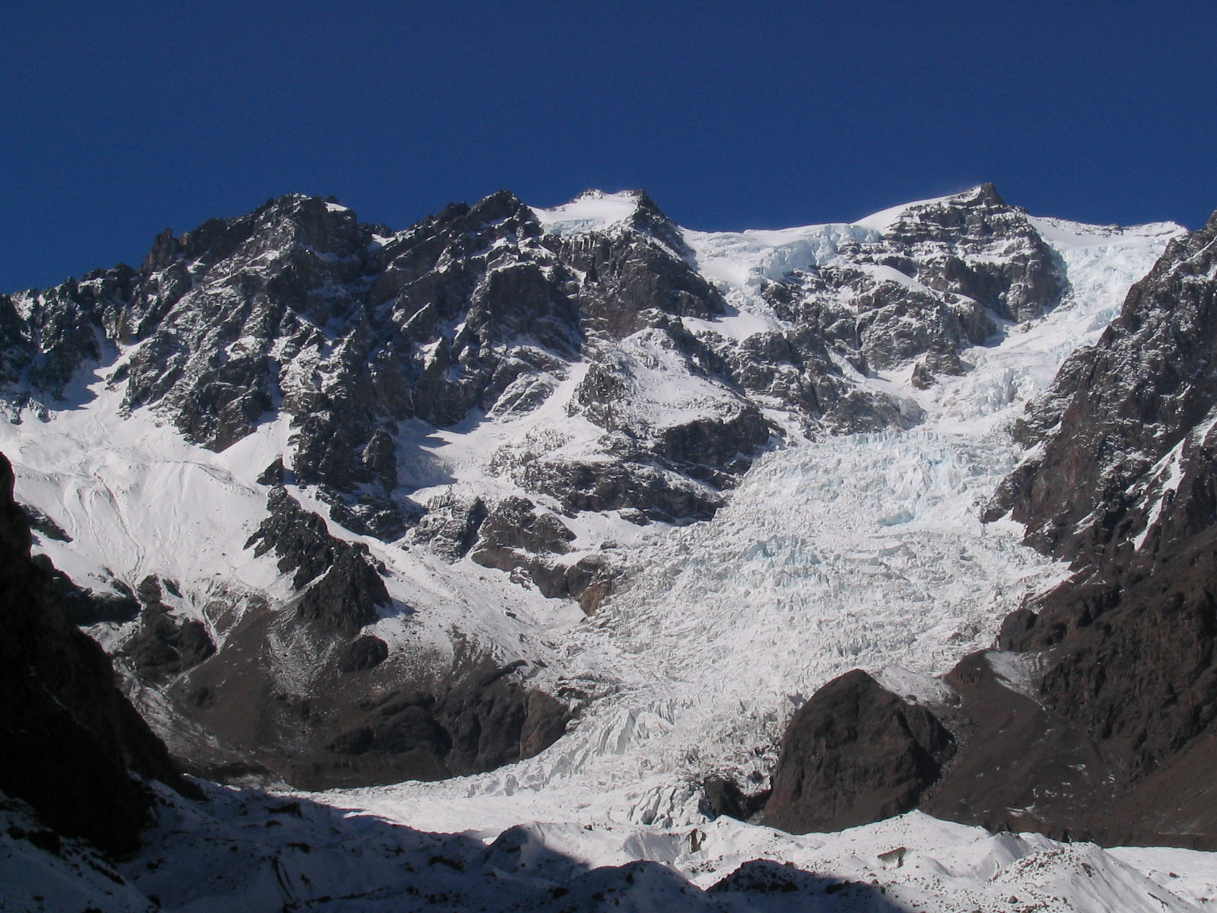
Nevado de Juncal (6.110m) Photo: Edison Acuña L.

Impressive Vista of North the Juncal glacier and summit of the Snow-covered Juncal. This hill is one of the most beautiful and imposing seismiles of Chile. It has a route of relatively easy scaling on ice, which constitutes a beautiful challenge for the lovers of the heights. The altitude gain until the summit is of about 3,000 ms from the base of the wall.

The sport challenge that represents this mountain, and their scenic beauty makes a scene ideal to show the mountain resources of our country.
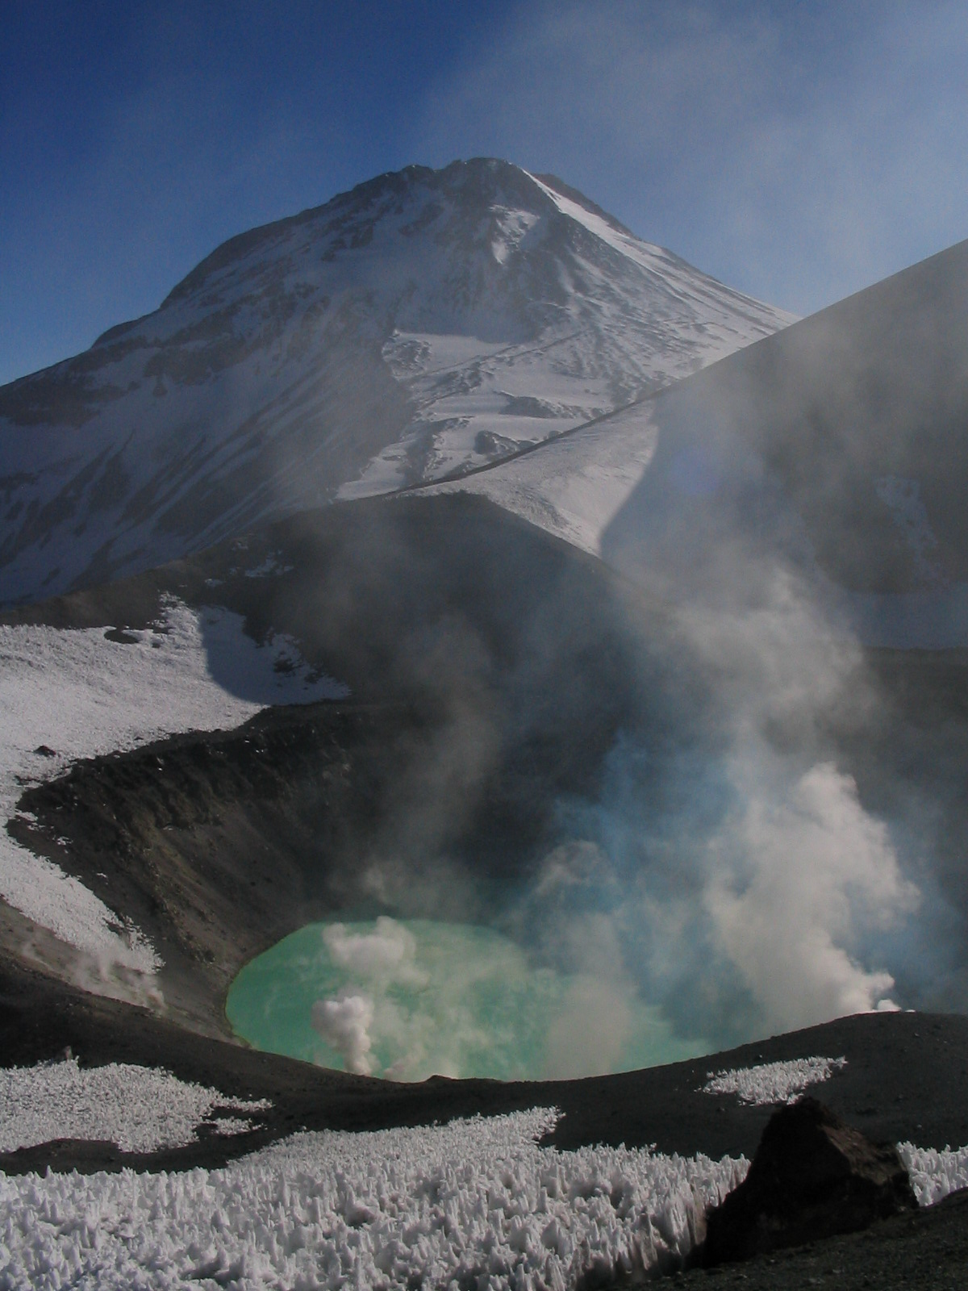
Tupungato Volcano (6.570m) Photo: Edison Acuña L.

The sulfur-like color of waters of the crater of Tupungatito volcano, they emphasize to the dawn and the fumarolas give a phantasmagoric aspect him to the impressive bulk of Tupungato volcano.

Being state lands, it seems natural to turn all the area a great national park, in where the sport activities of tourism could be developed freely and as it corresponds to a civilized country and with a strong tourist vocation like Chile. The present situation diametrically is opposed, where the mining and electric generation companies as well as land owners destroy and alter valleys irremediably and in addition impose restrictions to the access which they cause that these wonders practically stay forbidden for the immense majority

Perhaps an uprising makes lack of the authority to obtain a balance of long term that establishes the future priorities, to make fulfill the norms environmental and demand an enterprise conduct respecting the rules of the social responsibility (RSE)

In this sense, expedition UPAME 2007 represents an enormous opportunity to put in perspective the necessity to support and to fortify the institutional necessities that they defend our cordillerano patrimony and harnesses associated the sport and tourist development to mountains.

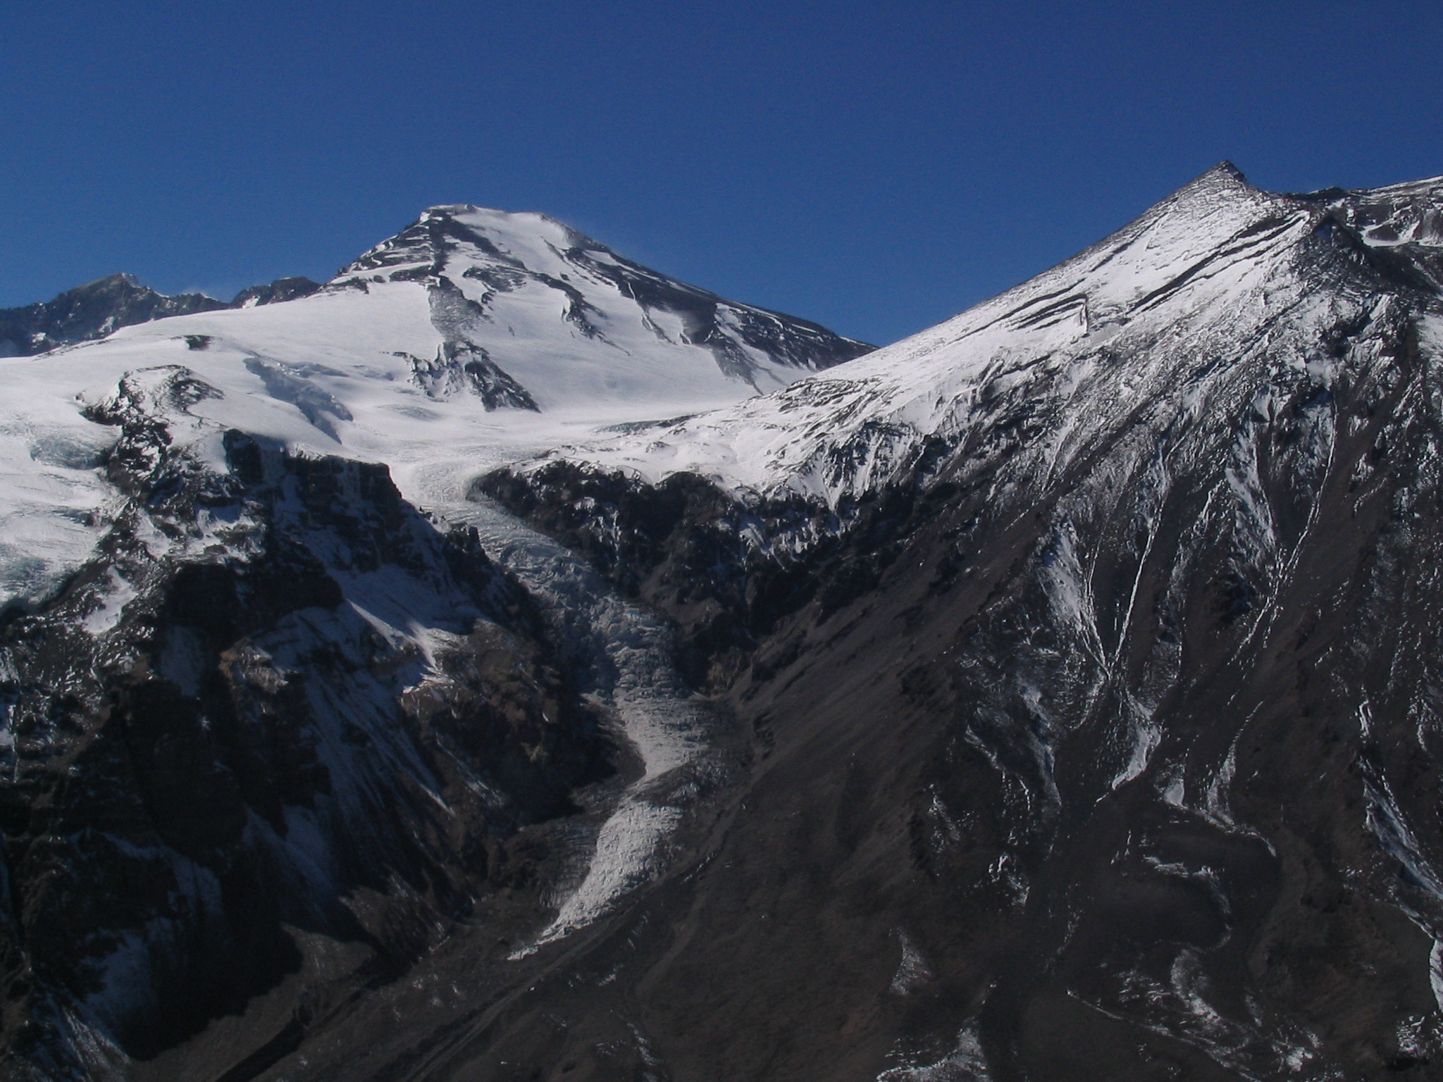
Mount Marmolejo (6.108m) Photo: Edison Acuña L.

To the left the hill is Marmolejo Mount seen from the southwest and a part of San Jose Volcano, to the right. The glacier that is come off the Marmolejo falls about 1,500 to 2,000 mts towards the valley of Mesoncito. Photo taken from the summit of the Mohai hill in the valley of the Mesoncito.

The Marmolejo Mountain, is the most austral seismil of the world. It marks the South limit of the great set of seismiles that exist in the cordillerano bulk of Aconcagua - Maipo and comprises of one of the most popular areas of the country for the practices of sports and mountain tourism in the country.

3. OBJECTIVES

3.1. GENERAL OBJECTIVES:

a. To spread and to promote the practice of the mountaineering and climbing in America and the world.
b. To consolidate the dedicated organisms to develop the sports of mountain in America.
c. To foment integration between the mountaineers of the different regions from America.
d. To present the characteristics our country as mountain destiny.

3.2. SPECIFIC OBJECTIVES:

a. To know geography and the landscape Chilean the Andes specially the zone between the river basins of the rivers Aconcagua and Maipo, that conform the mountain abutment of the city of Santiago.
b. To raise the summit of the three sixthousands, Tupungato Volcano, Marmolejo and Snow-covered Juncal by the normal route and to flame the flags of the participant countries in summits of each mountain.
c. Development of the eco-tourism, mountaineering, trekking and adventure sports in the zone of Aconcagua - Maipo and the country.
d. To carry out scientific measurements to collaborate with the development of the science of the zones of high mountain.
e. To interchange techniques of ascent and reduction in snow and ice, with the mountaineers and climbers of the different world and Latin American federations.

f. To strengthen the structure of the Andinismo Nacional and the International.

4. GOALS
To obtain the participation of 40 climbers of all the countries of the world, members of mountain organizations grouped in the Federation the International of Associations of Mountain climbing (U.I.A.A.), and the Union Pan-American of Associations Mountain and Climbing (U.P.A.M.E).

5. ORGANIZATION

a. Organizing committee: Federation of Andinismo of Chile.

5.1. PEOPLE IN CHARGE

DIRECTOR GENERAL: Milton Saldivia Campos(presidencia@feach.cl) , President Federation of Andinismo of Chile

GENERAL COORDINATOR: Edison Acuna Leiton (eacuna@consultec.cl), Federation of Andinismo of Chile.

ASCENT HEAD: Juan Carlos Delgadillo, Escuela Nacional de Montaña.

5.2. DURATION AND DATES

The activity of 23 days will take to effect of the 08 30th of 2007.

5.3. GENERAL ITINERARY

January 8 and 9th
Reception in Airport, time to purchases of equipment and food.

January 10th, Exit towards the Chacayar sector in the approach towards the base of the Tupungato

January 20th, bus from Chacayar to refuge Los Hornos in the way to the base of the Nevados de Juncal.

January 25th, bus from refuge Los Hornos to the sector Puente Colina in Baños Morales in the base of the Marmolejo.

30th, bus from Puente Colina to Santiago.

5.4. LOCATION, CONDITIONS AND ITINERARY “VOLCANO TUPUNGATO” 6570 meters

The expedition will be in the Republic of Chile, Metropolitan Region, Basin of the Colorado River.

Geographic position Coordinates Latitude 33º 21´ 16´ S, Longitude 69º 46´ 7´ W

First ascent: the 12 of April of 1897 by Matthias Zurbriggen and Stuart Vines.

DAY 1. JANUARY 10th: From Santiago we will go towards the possession of Customs officers of Chile, in the town of San Jose de Maipo, to sight and to stamp the permissions of (DIFROL) Borders Commission, and the hydroelectric company (GENER). We went to the sector of Alfalfal where we will present/display the authorizations of entrance, once made east control, we will follow about 20 km. Until the matting of Chacayar where they will be waiting for our carriers and the load animals (mules). Here our approach begins by a footpath to the flank this of the Colorado river, after 4 hrs. We will rest in the sector of Baños Azules, soon we will continue until Aguas Buenas 3 hours away. Where we will install our first camping.

DAY 2. JANUARY 11th: We will leave with direction towards Baños del Tupungato 4 hrs. Where we will take a break in the march to take a collation in this beautiful place. In the evening we will happen through the flank of the unmistakable Biscocho hill by its peculiar form. At dusk we will arrive at the fertile Los Flojos meadow, in this place we will install our BC.

DAY 3. JANUARY 12th: Day destined fundamentally to the acclimatization of the expedition, rest, feeding and the preparation of the equipment that will be used in the following campings. Also in this place we will be able to leave a food deposit for the return.

DAY 4 JANUARY 13th: We initiated the day by the flank of the river, towards the hill of Don Jose Maria Castillo, we continued by a drawer that took to us direct towards the camping of the landmark to 4700 TM. (Camping 1)

DAY 5 JANUARY 14th: This day we can use it of acclimatization or we can advance towards camping 2 to 5800 TM.

DAY 6 JANUARY 15th: Camping 2 to 5800 TM. This is a zone of much cold wind and mocho

DAY 7 JANUARY 16th: Attack to the summit of Tupungato Volcano, this volcano counts of two 6570 North and South summits being the second highest one of TM. Reduction to camping 2

DAY 8 JANUARY 17th: Reduction to the fertile Los Flojos meadow.

DAY 9 JANUARY 18th: Slope to the camping Aguas Buenas

DAY 10 JANUARY 19th: Exit towards the Chacayar matting.
DAY 11 JANUARY 20th: Bus towards refuge Los Hornos V Region.

5.5. LOCATION, CONDITIONS AND ITINERARY “SNOW-COVERED JUNCAL” 6110 METERS.

The expedition will take to effect in the Republic of Chile, Region, of Aconcagua, Drawer of the Juncal river

Geographic position Latitude 33º 2´ 25´ S
Longitude 70º 5´ 1´ Or

First ascent: 17 the January of 1911 by Federico Reichert, Robert Helbling and Damasio Beiza.

DAY 1 JANUARY 21th: they load mulares and we entered by the drawer of the Juncal, first km. They are by a way of vehicles until arriving at a small small village, we continued the entrance to arrive at the drawer of Water Monkeys, rest and lunch. We continued by the drawer of the Juncal until the beginning of the glacier, depending on the terrain conditionses, most probable is than this it will be the place to where they will leave the carriers us, soon we Keep moving on the glacier. This glacier is enough plane and it does not present/display greater difficulties, at the end of this glacier we will install our first camping.

DAY 2 JANUARY 22th: We initiated the day by a slope of 25º to 30º until arriving at a sector from rocks, once surpassed the obstacle we will follow by a glacier with cracks and below an enormous wall that will lead to us towards a canal that finishes in a small edge, possible place of the camping Nº 2

DAY 3 JANUARY 23th: Raised to 02 A.M., attacks towards the summit of the Snow-covered Juncal, the route is composed by mixed ground earth, rock, ice, glacier and snow, therefore it is necessary to have complete equipment.

DAY 4 JANUARY 24th: we struck camp Nº 2 and we descend haci the camping from Water Monkeys.

DAY 5 JANUARY 25th: They load mulares and we went to the Hornitos refuge, we loaded the bus to direct us to the Drawer of the Maipo, sector of Bridge Hill.

5.6. LOCATION, CONDITIONS AND ITINERARY “MOUNT MARMOLEJO” 6108 METERS

The expedition will take to effect in the Republic of Chile, Metropolitan Region, Colina river basin.

Geographic position Latitude 33º 43´ 52´ S
Longitude 69º 52´ 33´ Or
First ascent: January of 1928 by Albrecht Maas, Hermann Sattler and Sebastián Krückel

DAY 1 JANUARY 26th: The mules load themselves and begins our itinerary by a track towards the Valley of Fattens It, we crossed the multiple arms of the river, this would take us more from some annoyance since in it is time of the year the rivers and matting they come very grown, to take the necessary precautions like by ej. To take a pair of slippers párale negotiation of water obstacles, at the end of the valley begins the ascent by the Colina river until portezuelo Divisadero, takes direction this until a plateau from red earth of 4100 TM. Camping Nº 1

DAY 2 JANUARY 27th: A second camping in short time of ascent to about 5000 can be obtained TM. Ideal place for a good camping

DAY 3 JANUARY 28th: exit to 2 A.M. in the direction of the top, this zone is enough exposed to the North wind reason why good clothes of shelter are recommended. The North summit is the term of the slope, finishes in farallón towards the east, return to the camping Nº 2

DAY 4 JANUARY 29th: From the camping Nº 2 it is descended to the valley from Fattens It in where we will find pleasant fertile valleys for a deserved rest.

DAY 5 JANUARY 30th: We crossed more early possible to avoid the swelling of the rivers and matting of this beautiful place. From bridge Hill we will return to Santiago of Chile.

Note: To bring full field equipment for high mountain, including cover to sleep and helmet obligatorily.

Plástics boots in order to avoid exposure
Gaiters
Duvet Jacket
Harness
Carabiner con seguro
2 Carabiner sin seguro
2 estacas por cordada
Ice Axe tool
Crampons
Sun Glasses
Gloves
Mitts
Tent, camping & cooking gear.

The feeding in the mountain is responsibility of the participants. The fuel is of responsibility of the organizers.

6. CHARGES

the cost of the complete expedition is of 300 USD by participant, for which inscription limit will have to be paid to 150 USD to the date December 31th. The balance will be paid arriving at Santiago. One is allowed to separately make mountains to a cost of 150 USD each, with a payment of 100 USD to the date of the inscription.

7. INSCRIPTIONS AND LOGISTICAL SUPPORT

The inscriptions will be received until the 31 of December of 2006, in the direction Almirante Simpson 77, Santiago of Chile or by email to David Munoz asumo0@gmail.com.

The international and provincial delegations will have support in:

7.1 Transport to the Airport. International "Commodore Arturo Merino Benítez" Airport - Santiago - Airport

7.2 Lodging in Santiago. Days January 8th and 9th and January 30th. Meals included: dinner January 9th, breakfast January 10th, and dinner January 30th

Milton Saldivia Campos
President
Federación de Andinismo de Chile

Santiago, December 10th, 2006. CHILE
P.D.
Contacts:

Edison Acuña eacuna@consultec.cl

Phone +5622366067 +5624947270 +5698718383

Milton Saldivia presidencia@feach.cl

David Muñoz asumo0@gmail.com

Federacion de Andinismo de Chile
Almirante Simpson 77, Providencia, Santiago, CHILE
Baquedano. Subway Station
Phone: +5622220888, Mobile +5698718383

