IFSC CLIMBING WORLDCUP 2008
MOSCOW, Russia – OCTOBER, 31 - NOVEMBER, 1 - 2
BOULDERING + SPEED
1. ORGANISATION:
Climbing Federation of Russia:
8 Luzhnetskaya Nab., Moscow, 119992, Russia, tel/fax: + 7 495 725 47 04
e-mail: info@c-f-r.ru
Organizers: tel: +7 925 772 0461, fax: + 7 495 670 4501/00,
e-mail: president@c-f-r.ru , person-in-charge – Bytchkov Dmitri

IFSC Delegate – Marco Scolaris
Chief Routesetter – Percy Bishton
President of jury – Francois Leonardon

2. PARTICIPATION:
Each national federation: 3 male and 3 female competitors for each category
The host federation: 6 male and 6 female competitors for each category

The first 10 women and men listed on the WR at the registration deadline and those
placed first in the latest World Championships and the latest Youth Continental
Championships and who fulfill the age requirement in accordance with article 7.1.3,
shall have the status of extra-quota competitors and can be registered on top of the
quota stated above. Any other supplementary participants need to be approved by
the IFSC according to the rules (7.3.1).

IMPORTANT: In order to get Russian visas in time and minimize the prices,
Citizens of Austria, Belgium, Bulgaria, Hungary, Germany, Greece, Spain, Italy, Chyprus (except for northern part of island), Latvia, Lithuania, Luxembourg, Malta, the Netherlands, Poland, Portugal, Romania, Slovakia, Slovenia, Finland, France, Czechia, Sweden, Estonia can send data on the visa in the form of the table (see Appendix 1), not applying a copy of the passport.
Citizens of other countries please send completed visa application form (see Appendix 2) and copy of your passport valid a minimum 6 months from the moment of departure the Russian Federation, by e-mail.

info@c-f-r.ru or by fax: +7 495 670 4501/00
DEADLINE for free Invitation – September, 15th !!!
After this date the price shall be charged from 30 to 60 Euro per person!

3. TRAVEL DETAILS: by plane: Moscow International Airports: Sheremetevo 2 or Domodedovo.
The meeting of teams at the airport and transported to the Hotel. The price is 10-20 Euro per person.
As it is possible to reach by train station in Moscow, further to go by the underground.

4. APPLICATIONS
Please use the online registration http://www.ifsc-climbing.org/egroupware/
and copy to:
Organizers – info@c-f-r.ru , fax: + 7 495 670 4501/00

Deadline for registration: 18.00 GMT Sunday 25 OCTOBER 2008

VERY IMPORTANT. We remind that:
1. Those competitors for whom their belonging Federations have not applied for an International License, will NOT be allowed to compete.
2. Deadlines for registration of competitors reported in the competition information sheets disseminated by the IFSC must be respected by each member federations.
3. Registrations after the deadline are subject to an extra fee.
4. Competitors’ registration fees will be charged to the member federation when registered competitors do not attend the concerned event, unless the IFSC has been informed earlier than 4 days prior to the event (considering the 1st day of competition).

5. PRIZES: According to IFSC Standards.

6. OFFICIAL FACES:
IFSC delegate – Scolaris Marco
Chief routesetter – Bishton
President of jury – Leonardon.

7. ACCOMMODATION:
Hotel ***
Single room –50 - 60 ∈ per person per night
Double bed room – 40 -70 ∈ per person per night.
Number from 4 rooms on 5 person from a general bathroom – 45 ∈ per person per night.
Room reservation is made after an advance payment. The additional information after August, 15th

Hotel reservation:
popoff@jettravel.ru
Tel +7 916 461 07 08
Deadline: not later than September, 15th.
Please send the following information: passport data, place of residence, arrival and departure dates.

8. COMPETITION VENUE: “Gostinyi dvor”, Ilinka, 4, Moscow

9. COMPETITION WALLS:
i) Boulders (see the pictures below):

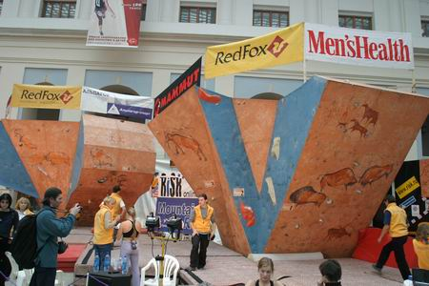
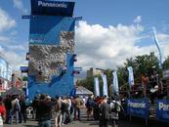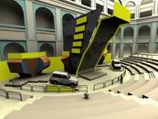

ii) Speed: height 14 m, overhanging 3-4 m.
All this constructions will be indoor.

10. TECHNICAL MEETING:
Thursday, 30th , 18.00 - “Gostinyi dvor”, Ilinka, 4, Moscow

11. PROVISIONAL PROGRAMME:

Friday, 31th BOULDERING
Male Qualification Starts
Female Qualification Starts

Saturday, 1th BOULDERING
Semifinal (Female, Male)
Final (Female, Male)
Following Awarding Ceremony.

Sunday, 2th SPEED
Qualification Starts (Female, Male)
Final (Female, Male)
Awarding Ceremony, Farewell Party

More info: www.c-f-r.ru

IFSC CLIMBING WORLD CUP 2008
MOSCOW, Russia – OCTOBER, 31 - NOVEMBER, 1 – 2

Appendix 1
 |  | INFORMATION REQUIRED FOR THE VISA INVITATION
full name | date of birth | gender | citizenship | passport number | expiry date | city of visa application | Contact tel.,fax, e-mail
as in passport

Appendix 2

Visa application form

- Last name ____________________ First name

- Federation

- Birth date (date/month/year)

- Birth place

- Sex (male/female)

- Profession

- Nationality

- Passport number ___________ issue date ______________ expiry date

- E-mail

- Date of arrival ______________________date of departure

PLEASE ATTACH YOUR PASSPORT COPY
(The passport must be valid at least 6 month after the last day of the suggested stay in Russia)

Due to the complicated visa procedure please submit this form as soon as possible but not later than September, 15st, 2008.

Email: info@c-f-r.ru

