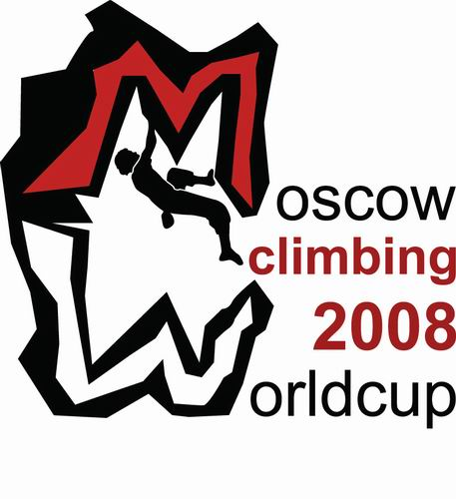
  Organization committee:  CLIMBING FEDERATION OF RUSSIA | 419a, Luzhnetskaya Nab., 8, Moscow, 119992  tel./fax: (495) 725-4704, E-mail: info@c-f-r.ru  Web: www.c-f-r.ru
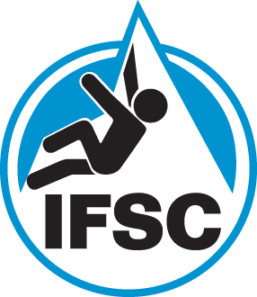 | PROVISIONAL PROGRAMME:  Friday, 31th BOULDERING  12.00 – 13.00 Opening ceremony  13.00 – Male and female Qualification Starts  Saturday, 1th BOULDERING  11.00 – Semifinal starts(Female, Male)  17.00 – Final starts (Female, Male)  18.30 – Awarding Ceremony flower,  Sunday, 2th SPEED  11.00 –Qualification Starts (Female, Male)  15.00 –Final starts (Female, Male)  17.00 – Awarding Ceremony,  20.00 – Farewell Party (La Sportiva Party)
  Place of competitions:
  XV International Ski Salon
  Moscow, Il’inka street, 4. Gostiny Dvor
